Computational Analysis of Gene Expression Progression in Early-Stage Breast Cancer (GSE16873)
Fareed Dubiure.
Abstract
Public microarray data (GSE16873) (GEO Accession Viewer, n.d.) was analyzed using Python to identify gene expression changes across four progressive breast tissue lesion stages: histologically normal, simple ductal hyperplasia, atypical ductal hyperplasia, and ductal carcinoma in situ. Differential expression analysis revealed distinct transcriptional suppression in early transformation, with ACTA2 showing a steady negative progression suggestive of cytoskeletal disorganization. This computational workflow highlights a candidate biomarker involved in early breast tumorigenesis.
Introduction
Breast cancer remains the world’s second leading cause of cancer-related deaths among women (Giaquinto et al., 2022). Early detection and characterization of molecular or genetic changes that occur prior to invasive carcinoma are critical for diagnosis and improving patients’ outcome through preventive strategies. Histologically, breast tissue undergoes significant progression from normal epithelial tissue to ductal carcinoma in situ (DCIS), which is a pre-invasive stage of breast cancer development (Allred et al., 2008). Two intermediate progressive stages known as the simple ductal hyperplasia(SDH) and atypical ductal hyperplasia (ADH) precede the DCIS stage and have unique progression characteristics.
While the morphological appearance and changes during this progression are well characterized, the transcriptional or genetic alterations driving the progressions are less understood. Analyzing how the expression of different genes change during the different stages of progression could provide insight into the molecular mechanisms behind this transition and may reveal biomarkers that could help with early diagnosis. Understanding how normal tissue transitions to DCIS at the molecular level could also inform the development of early diagnostic tools.
In this study, publicly available microarray data (GSE16873) were analyzed to identify genes that change in expression during early breast cancer progression. Computational methods in Python were used to perform differential expression analysis and visualize gene expression trends across the four mentioned histological stages. By focusing on statistically significant and biologically meaningful changes, this study aims to highlight key genes associated with early tumorigenic transformation, including those showing consistent up- or down-regulation patterns.

Methods
Gene expression data were obtained as a series matrix file from the NCBI Gene Expression Omnibus (GEO) database under accession number GSE16873. The dataset contains microarray expression profiles from 40 human breast tissue samples, each classified into one of four histological categories: histologically normal (HN), simple ductal hyperplasia (SDH), atypical ductal hyperplasia (ADH), and ductal carcinoma in situ (DCIS). The samples were isolated from within patients with ER+ sporadic breast cancers via laser capture microdissection and analyzed via Affymetrix U133A microarray.
The dataset was downloaded and processed in python using libraries such as Panda, SciPy, Statsmodels, and NumPy. Samples were grouped according to their histological classifications, resulting in four sample lists corresponding to the four tissue types. The mean of each group was calculated. The main expression data was loaded into a data frame with the rows corresponding to the gene probe IDs and 40 columns each representing a sample. The plan was to first assess the differential expression between the HN and DCIS samples and then track the expression of the most significant genes through the four stages.
Differential expressions between the HN and DCIS samples were assessed using a t-test by first computing the base2 log of the fold change between the samples.
i.e., Log2fold change = Log2(mean of DCIS/ mean of HN)
Using the base2 log made it easier to plot the gene expression since upregulated genes will have a positive fold change and upregulated genes will have a negative fold change. The t-test was then conducted. A threshold was chosen for which genes’ expression would be considered to be significantly altered. A gene was considered significantly differentially expressed if it exhibited an absolute log₂ fold change greater than 1 (indicating at least a twofold difference) and a p-value less than 0.05.
The results were compiled into a new data frame containing the gene IDs, their fold change, their p values, and whether a gene was considered significant. Significant genes were visualized using a volcano plot (a scatter plot with threshold lines) of p-values against fold change. Overall, 664 of the 22,283 genes were found to be significant. Next the results were arranged in ascending order of p values, in order to get the top 10 genes with the highest correlation across the two groups. These mean values of these top 10 genes across the four stages were then plotted to examine which showed steady progression trends. One gene (or rather the ID of one gene) showed significant negative progression from HN all the way to DCIS stage.
Since our original file only contained the IDs of the genes without their names, the annotation file corresponding to the microarray used was downloaded and loaded into python. The gene names were matched to the IDs and added to the results data frame. The gene that showed a clear and consistent negative progression was identified to be the ACTA2 gene.

Results
A total of 22,283 probe sets were analyzed. By our defined threshold, the differential expression between DCIS and HN breast tissue identified a set of 664 out of the total genes that were significantly altered in expression. The volcano plot (Figure 1) visualizes both the magnitude and statistical significance of expression changes. Genes with large fold changes and low p-values clustered toward the upper corners of the plot. Upregulated genes appeared on the right-hand side (positive log₂FC), while downregulated genes appeared on the left (negative log₂FC). Among the significant genes (shown in red), there was a slight majority of them that showed downregulation, though a good number also showed upregulation. The top 10 genes, according to the least p-values, resulted in 10 downregulated genes.
Trend plots across the four histological stages revealed two of the top 10 genes exhibited significant variable expression, with ACTA2 displaying a consistent negative progression across the four stages (fig2). Together, these results highlight clear transcriptional shifts in some genes during the transition from normal to pre-invasive breast tissues The consistent downregulation of ACTA2 provides molecular evidence of its correlation with early tumorigenesis.
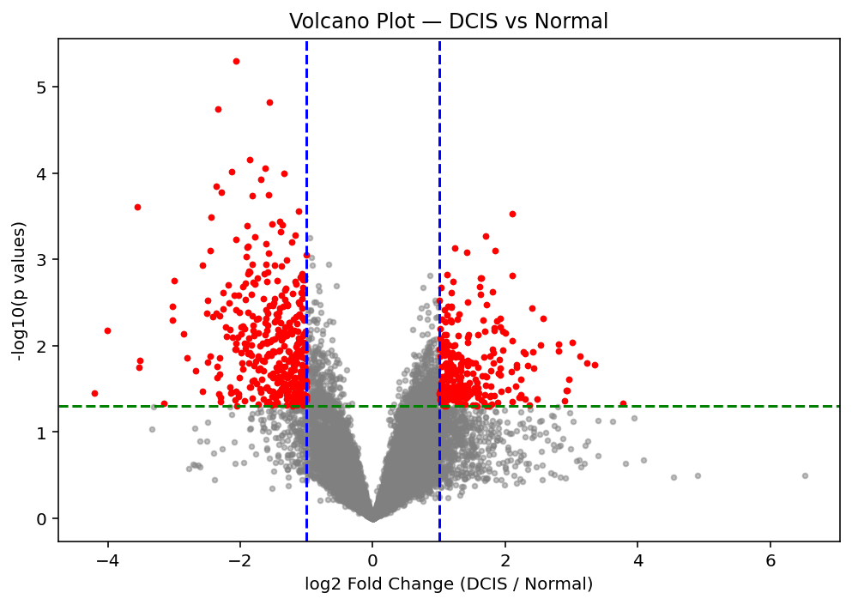Fig1. Scatter plot of p-values (taken to the -log) against the fold change (taken to the log base 2) of studied genes. Higher points infer a low p-value and high fold change, making the gene more significant (in red). Threshold lines drawn for p<0.05(blue line) and log2 fold change >1(green line)
Table 1: Top 10 significant genes obtained by least p-values, with their log2 fold change and gene names.
p values | log2FoldChange | Gene Name
0.000005 | -2.063334 | PDLIM4
0.000015 | -1.565018 | CRYAB
0.000018 | -2.341500 | NSG1
0.000070 | -1.855136 | ACTA2
0.000087 | -1.625547 | KRT15
0.000096 | -2.136442 | CHST3
0.000101 | -1.342182 | CHST3
0.000117 | -1.689191 | TP63
0.000142 | -2.367485 | SCN3A
0.000166 | -2.289219 | FMO2

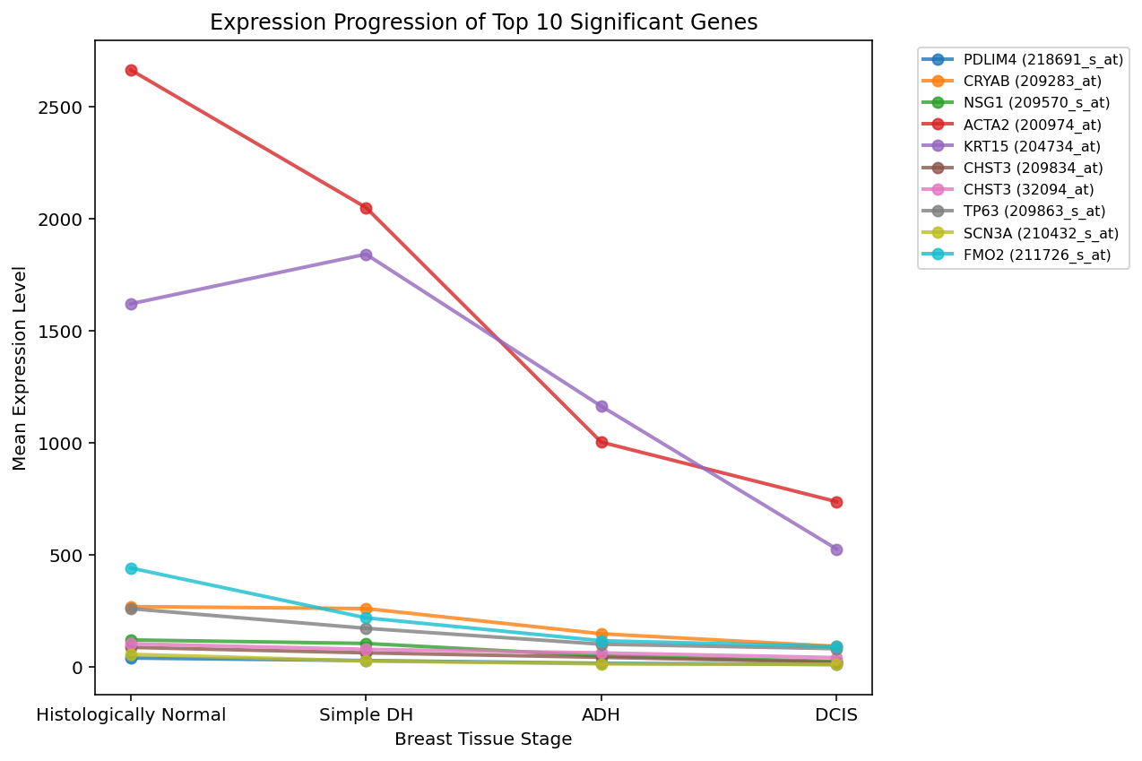Fig2. Trend plots for top 10 significant genes across the four distinct tissue stages. ACTA2(in red) shows a steady negative progression from histologically normal tissue all the way to DCIS stage.

Discussion
The goal of this project was to identify genetic expression patterns associated with early breast cancer development and to determine whether distinct genes exhibit consistent progression trends across these pre-invasive stages. Contrary to the common expectation that neoplastic transformation is accompanied by widespread transcriptional upregulation, most significantly altered genes in this dataset were downregulated in DCIS compared to normal tissue. This observation suggests that early transformation in breast epithelium may involve the suppression of genes associated with normal cellular structure and differentiation, rather than immediate activation of oncogenic programs. Such a pattern is consistent with a biological shift from a stable, differentiated state toward a more disorganized and less specialized phenotype, which is a hallmark of early tumorigenesis.
Analysis of expression trends across all four histological stages revealed that only two of the top ten genes exhibited significant variation across the progression. Of these, ACTA2 (Alpha Smooth Muscle Actin) showed a distinct and consistent negative progression from normal tissue through SDH, ADH, and DCIS. This gene encodes a cytoskeletal actin protein crucial for maintaining epithelial and stromal structure. Its continuous downregulation supports the notion that loss of myoepithelial integrity and cytoskeletal organization are among the earliest molecular events in breast cancer development. This aligns with previous studies linking reduced ACTA2 expression to epithelial-to-mesenchymal transition (EMT) and loss of differentiation in pre-invasive breast lesions (He et al., 2025). The second gene showing progression exhibited a less consistent pattern, with mild upregulation in simple ductal hyperplastic tissue followed by downregulation in DCIS, suggesting that expression changes during transformation may be nonlinear and context dependent.
Although these findings reveal clear patterns of transcriptional suppression, several limitations should be noted. The dataset analyzed here is based on microarray intensity values, which provide relative rather than absolute measures of gene expression. Additionally, protein-level analyses were not performed, limiting functional interpretation. Future studies could integrate pathway enrichment analysis to confirm whether ACTA2 downregulation and related cytoskeletal remodeling consistently mark early tumor initiation across larger cohorts.
Overall, the results from this analysis suggest that early breast tumorigenesis is characterized less by broad transcriptional activation and more by loss of normal epithelial gene expression. The strong and consistent downregulation of ACTA2 across all stages points to its potential role as an early biomarker of myoepithelial deterioration and structural disorganization during the transition from normal to pre-invasive breast tissue.

References
Allred, D. C., Wu, Y., Mao, S., Nagtegaal, I. D., Lee, S., Perou, C. M., Mohsin, S. K., O’Connell, P., Tsimelzon, A., & Medina, D. (2008). Ductal Carcinoma In situ and the Emergence of Diversity during Breast Cancer Evolution. Clinical Cancer Research, 14(2), 370–378. https://doi.org/10.1158/1078-0432.CCR-07-1127
GEO Accession viewer. (n.d.). Retrieved November 10, 2025, from https://www.ncbi.nlm.nih.gov/geo/query/acc.cgi?acc=GSE16873
Giaquinto, A. N., Sung, H., Miller, K. D., Kramer, J. L., Newman, L. A., Minihan, A., Jemal, A., & Siegel, R. L. (2022). Breast Cancer Statistics, 2022. CA: A Cancer Journal for Clinicians, 72(6), 524–541. https://doi.org/10.3322/caac.21754
He, H., Xiang, L., Pi, B., Yang, J., Peng, W., Li, M., Liu, H., Zheng, X., Liu, H., Peng, Y., Zhang, P., Zhang, J., Chen, X., Zhang, Y., Shuai, M., Xu, F., Cai, Y., & Yuan, C. (2025). Unveiling the Vital Role of ACTA2-AS1 in Human Cancers: Molecular Mechanisms and Clinical Applications. https://doi.org/10.2174/0118715206381499250607114710

